**What do you mean by cells in an excel sheet?**

Cell is a rectangular box which occurs at the intersection of a vertical column and a horizontal row in excel worksheet.

Cell is a rectangular box occuring at the intersection of a vertical column and a horizontal row in excel worksheet.

Vertical columns are the ones that are numbered with alphabetic values such as A, B, C, D......

Horizontal rows the ones those are numbered with numeric values such as 1, 2, 3, 4, 5....

The main difference between columns and rows is that a column arranges data vertically from top to bottom and a row arranges data horizontally from left to right.

**How can you restrict someone from copying a cell from your worksheet?**

By default, when you protect a worksheet, all the cells on the worksheet are locked, and users cannot make any changes to a locked cell. To set a password to protect cells, follow the steps given below:

Go to REVIEW tab and click on "Protect Sheet" option.  
 Excel opens the Protect Sheet dialog box. By default, Excel selects the Protect Worksheet and Contents of Locked Cells check box.  
 Select any of the check boxes in the Allow All Users of This Worksheet To list box (such as Format Cells or Insert Columns) that you still want to be functional when the worksheet protection is operational.  
The Select Locked Cells and Select Unlocked Cells check boxes are selected by default.  
 Type the password in the 'Password to unprotect Sheet' text box.  
Click OK.  
Excel opens the Confirm Password dialog box. Re-enter the password in the Re-enter Password to Proceed text box and then click OK. Notice that if you try to edit a cell, Excel displays an error message.

**How to move or copy the worksheet into another workbook?**

Method 1. Copy Excel sheet by dragging

Usually, you drag-and-drop to move something from one place to another. But this method also works for copying tabs and is, in truth, the fastest way to copy a sheet in Excel.

Simply, click on the sheet tab that you want to copy, hold the Ctrl key and drag the tab where you want it:  
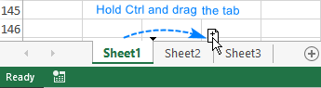

Method 2. Duplicate a sheet by right-clicking

Here's another way to duplicate a sheet in Excel that is just as easy:

Right click on the tab and select Move or Copy from the context menu. This will open the Move or Copy dialog box.

Under Before sheet, choose where you want to place the copy.

Put a tick in the Create a copy box.

Click OK.

For instance, that's how you can make a copy of Sheet1 and place it before Sheet3:

Duplicate a sheet by right-clicking it.

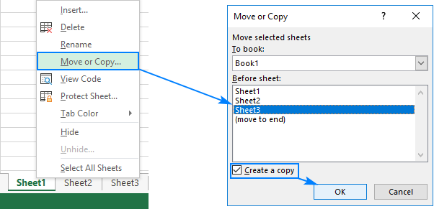

**Which key is used as a shortcut for opening a new window document?**

Ctrl +⇧ Shift

**What are the things that we can notice after opening the Excel interface?**

Tabs, Ribbon interface, Name box, Formula bar, Working area, Worksheet tabs

**When to use a relative cell reference in excel?**

Relative reference is a type of cell reference in Excel. This reference changes when the formula is copied to any other cell or any other worksheet. Relative cell references are used whenever calculations need to be repeated.